# Install gym Atari (pong is in this environment as a demo) in Windows

1. Install gym

pip install gym

pip install gym[accept-rom-license]

1. install VS build tools

* or we will have an error if we directly install gym Atari :

OSError: [WinError 126]

* If we have this error, we should uninstall gym[Atari]

pip uninstall atari-py

pip uninstall gym[atari]

* Then we download VS tools

<https://visualstudio.microsoft.com/thank-you-downloading-visual-studio/?sku=BuildTools&rel=16>

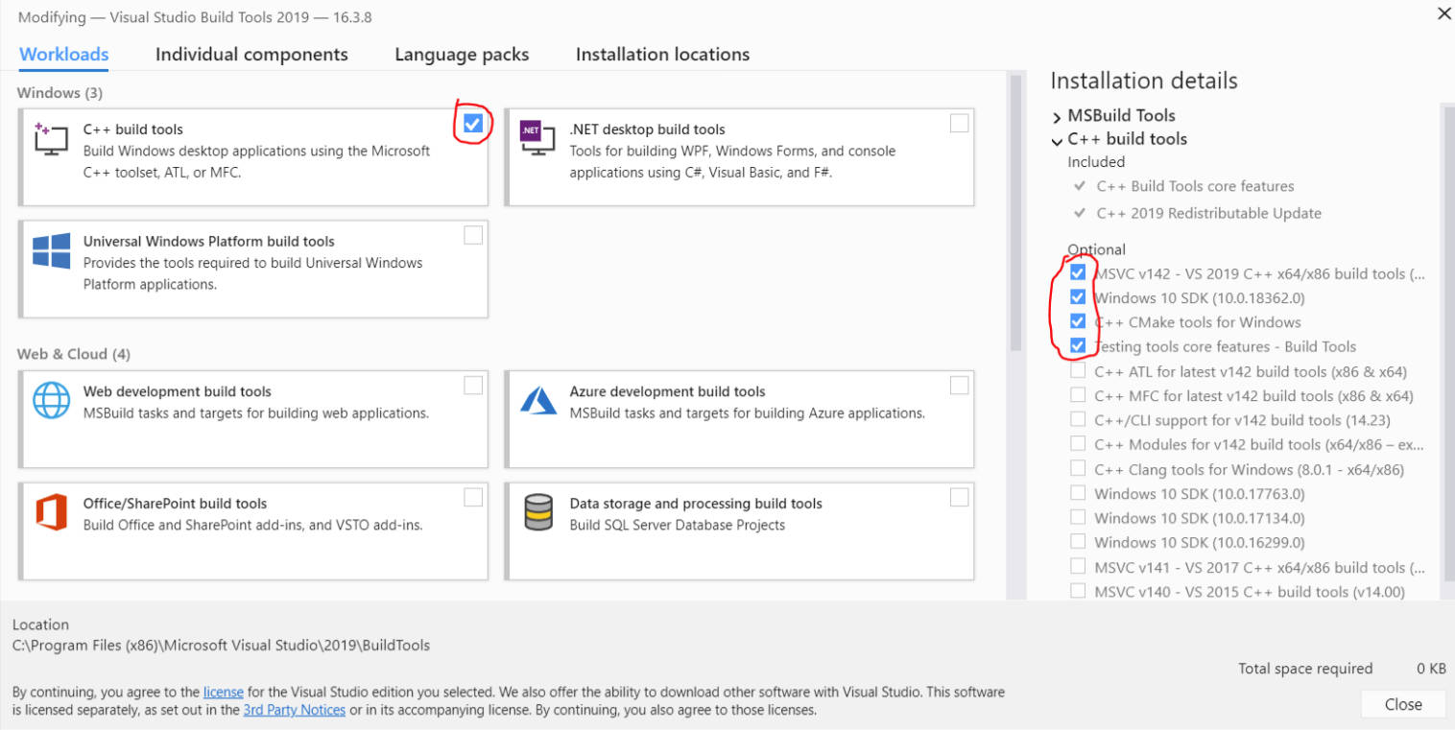

1. Restart the computer and run the commands

pip install cmake

pip install atari-py

pip install gym[atari]

1. Test gym in python

import atari_py

print(atari_py.list_games())

1. install box2d environment (optional)

* download swigwin

<http://www.swig.org/download.html>

* Extract the file and add the extracted root directory (xx\swigwin) to the environment variable: path

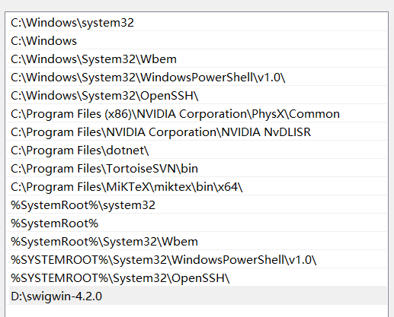

* Install box2d, ale-py, pyglet, opencv-python

pip install gym[box2d]

pip install ale-py

pip install pyglet

pip install opencv-python

1. if we are unable to find the game “pong”

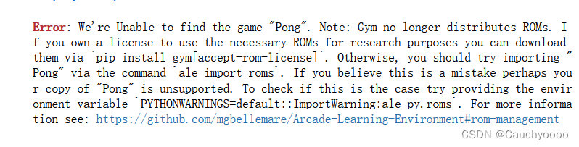

* Download a file in

<http://www.atarimania.com/rom_collection_archive_atari_2600_roms.html>

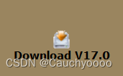

* Then extract this file
* Install autorom

pip install autorom

* + then import autorom

AutoROM –-accept-license

1. Check gym Atari:
   * Print the game names

import gym

from gym import envs

env_games = [spec.id for spec in env.registry.all()]

for name in sorted(env_names):

print(name)

* run the game “pong”

import gym

env = gym.make("Pong-ram-v4", render_mode='human') # ansi | human | rgb_array  
observation = env.reset()  
for t in range(1000):  
 #env.render()  
 action = env.action_space.sample()  
 observation, reward, done, _, info = env.step(action)  
 print(action)  
  
 if done:  
 observation = env.reset()  
env.close()